Exercise 1 - Implementing the Singleton Pattern
Created a new Java project named SingletonPatternExample –

Defined a Singleton Class:
Created a class named Logger that has a private static instance of itself. Made the constructor of Logger is private. Have provided a public static method to get the instance of the Logger class.
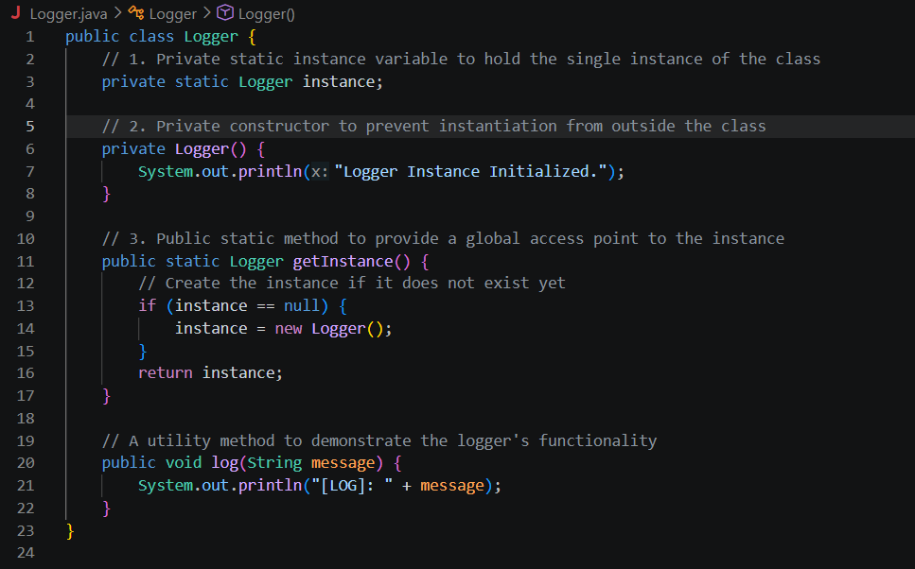
Implemented the Singleton Pattern and created a test class to verify that only one instance of Logger is created and used across the application.
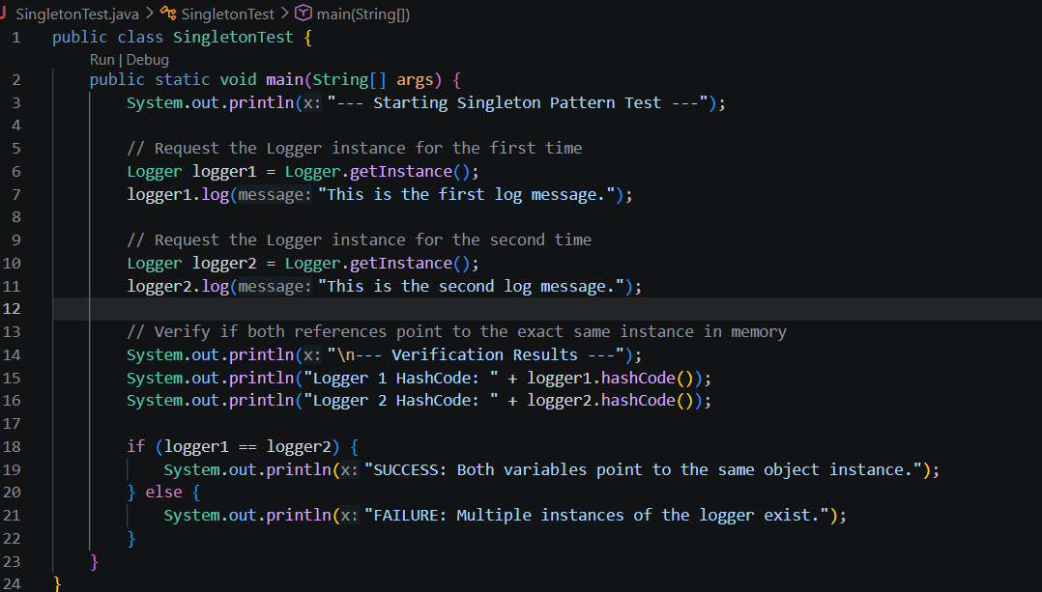
CODE OUTPUT –
